Exhibition and dialogue in London: “Art says things that history cannot"

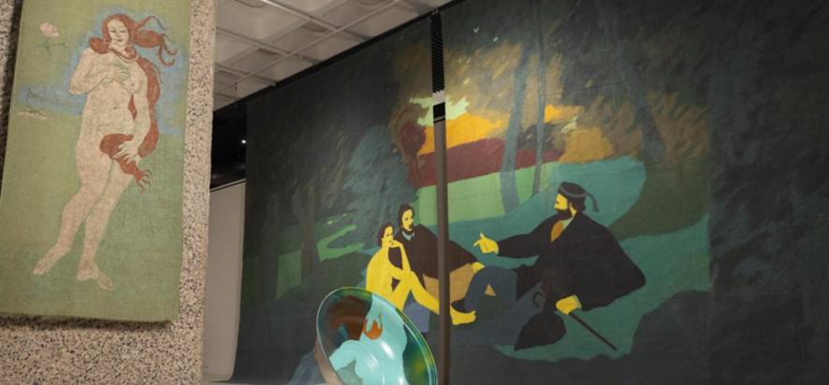

London, 18th of march 2026

The Embassy of Colombia in the United Kingdom, in partnership with Amalgama, has been fully committed to the retrospective currently being held at the Barbican on the work and trajectory of Maestra Beatriz González. This commitment has not been limited solely to its public engagement; it has been decided to have an active participation, proposing this conversation.

“Art Says Things That History Cannot” , was moderated by Daniela Galán, founder of Amalgama Art and Amalgama Academy, an international platform dedicated to the research, exhibition, and promotion of Latin American artists. Daniela is a lecturer with The Arts Society (UK) and has delivered talks at institutions such as Sotheby’s and Instituto Cervantes. She has over 20 years of research experience in art history and philosophy, with a particular focus on women artists from the region.
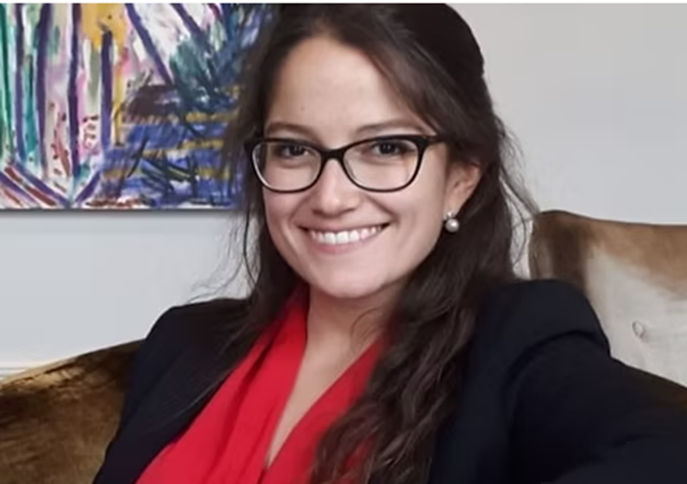

She joined in conversation by Gabriela Salgado, who served as Artistic Director of Te Tuhi Contemporary Art in New Zealand (2017–2020), where she curated exhibitions of artists such as Raúl Ortega Ayala, Carlos Cruz-Diez, and Gayle Chong Kwan, alongside shows by local artists. After working for six years at the University of Essex Collection of Latin American Art (UECLAA), she became Curator of Public Programmes at Tate Modern (2006–2011). In 2009, she curated the 2nd Thessaloniki Biennale (Greece), and in 2013, La Otra Bienal in Bogotá.
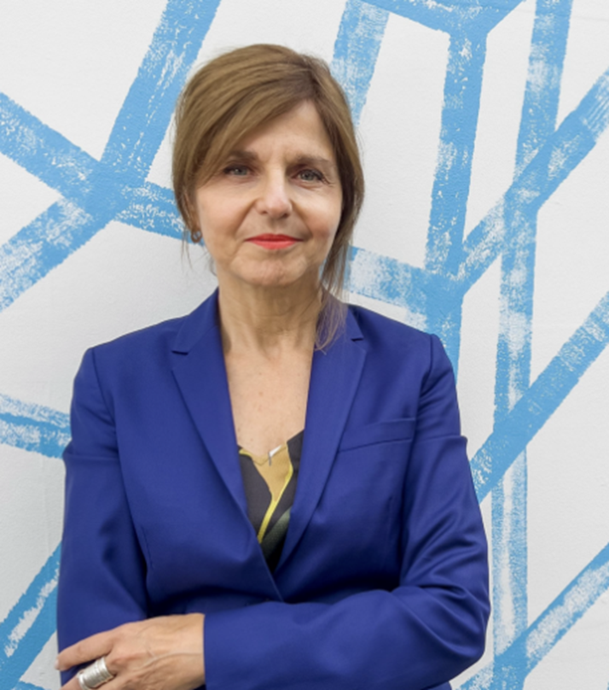
Gabriela Salgado. Photo: Emma Blau

The conversation also featured Maya Jaggi, a British writer, literary critic, editor, and cultural journalist. She was elected a Fellow of the Royal Society of Literature and holds an honorary doctorate (2012). She has contributed to publications including The Guardian, Financial Times, The Independent, The Literary Review, Times Literary Supplement, The New York Review of Books, The Wall Street Journal, The Economist, New Statesman, Wasafiri, Index on Censorship, and Newsweek. She is particularly recognized for her profiles of writers, artists, filmmakers, and other cultural figures.
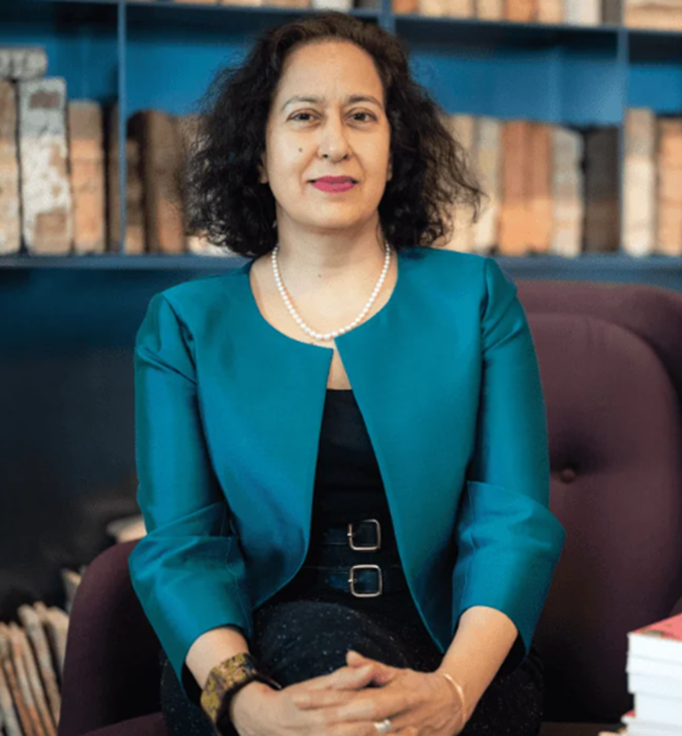
Maya Jaggi, Photo: Ale Di Padova/EBRD

The panel also included Lotte Johnson, curator of the exhibition, and art historian based in London. She has also served as lead curator of Unravel: The Power and Politics of Textiles in Art (2024, co-curated with the Stedelijk Museum Amsterdam) and Carolee Schneemann: Body Politics (2022), as well as solo commissions by artists such as Citra Sasmita (2025), Toyin Ojih Odutola (2020), SERAFINE1369 (2019), Yto Barrada (2018), and Bedwyr Williams (2016). She has contributed to other Barbican exhibitions and their accompanying publications, including Into the Night: Cabarets and Clubs in Modern Art (2019), Basquiat: Boom for Real (2017), and The World of Charles and Ray Eames (2015). She previously worked at the Museum of Modern Art in New York and regularly contributes to exhibition catalogues and publications, in addition to lecturing on modern and contemporary art.
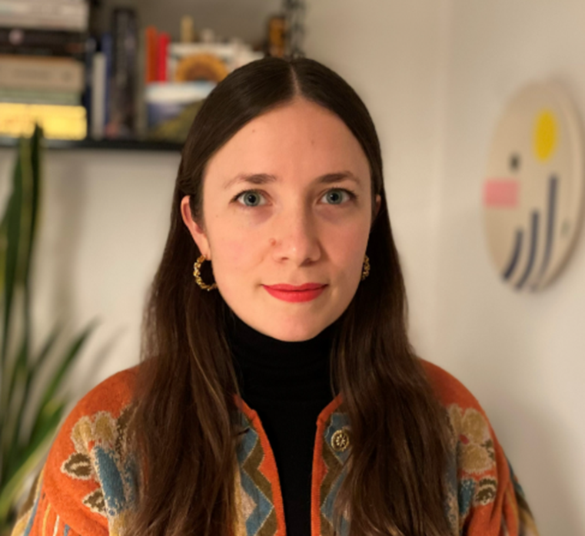

For the Embassy of Colombia, fostering this conversation, in the context of the retrospective of Maestra Beatriz González—one of the leading figures of Latin American art—constituted an opportunity to continue opening dialogues on the historical contexts of our country: memory, conflict, the relationship with power, and the simplification of complex realities in the media.
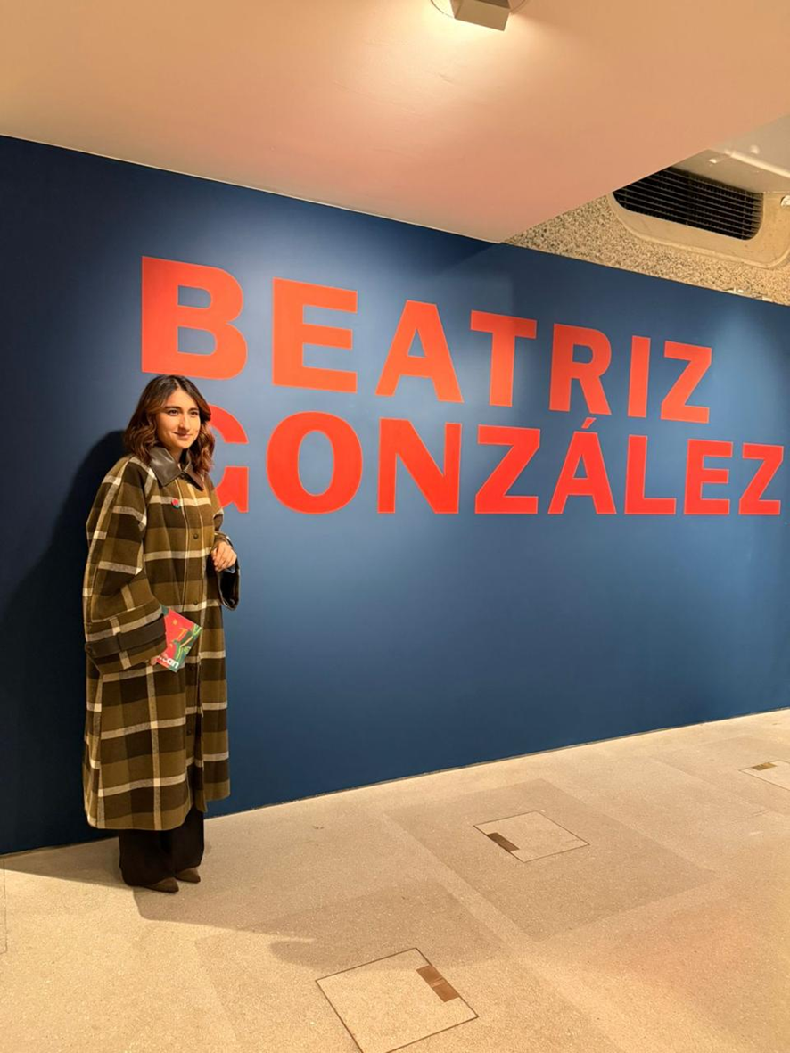

For this reason, “Art Says Things That History Cannot” was conceived as a starting point for a broader reflection to which this Embassy invites its audiences. As the Ambassador has noted: “Beatriz González leads me to reflect on the question of neutrality. Cultural spaces shape memory, knowledge, and imagination. Their legacy lies not only in exhibition, but also in the narratives they construct about who we are and how we relate to one another.”

This conversation forms part of the cultural diplomacy strategy of the Government of Colombia, which seeks to open spaces to address issues that are otherwise more difficult to confront. And what better way to do so, as talking about art—or, even better, through art.

